4.26: The box can be considered a single particle.
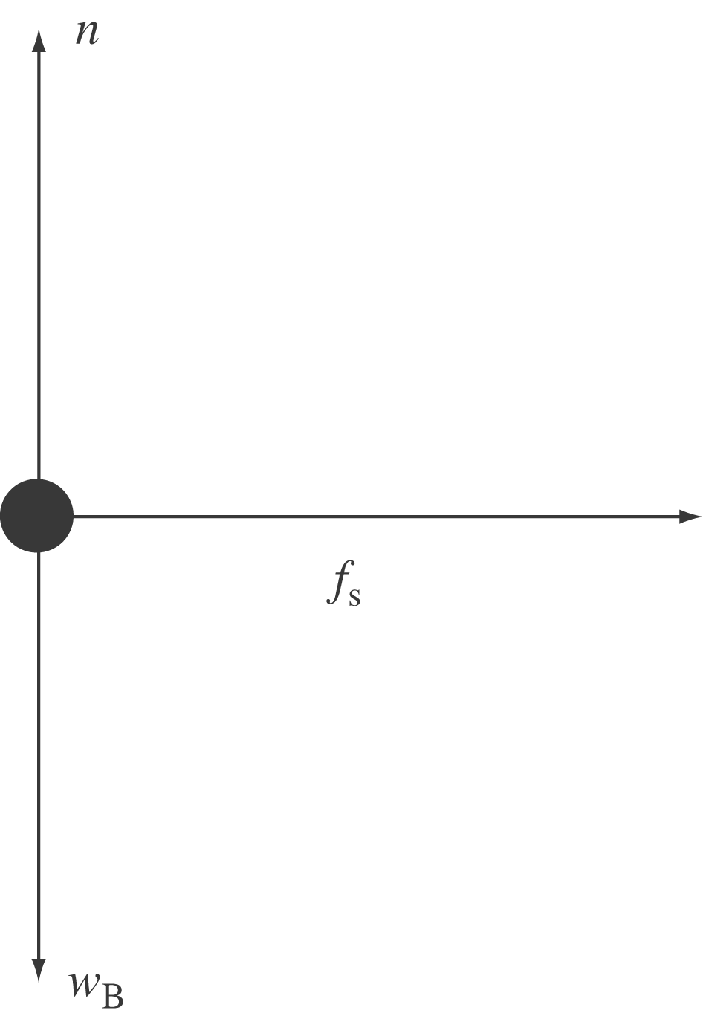
For the truck:
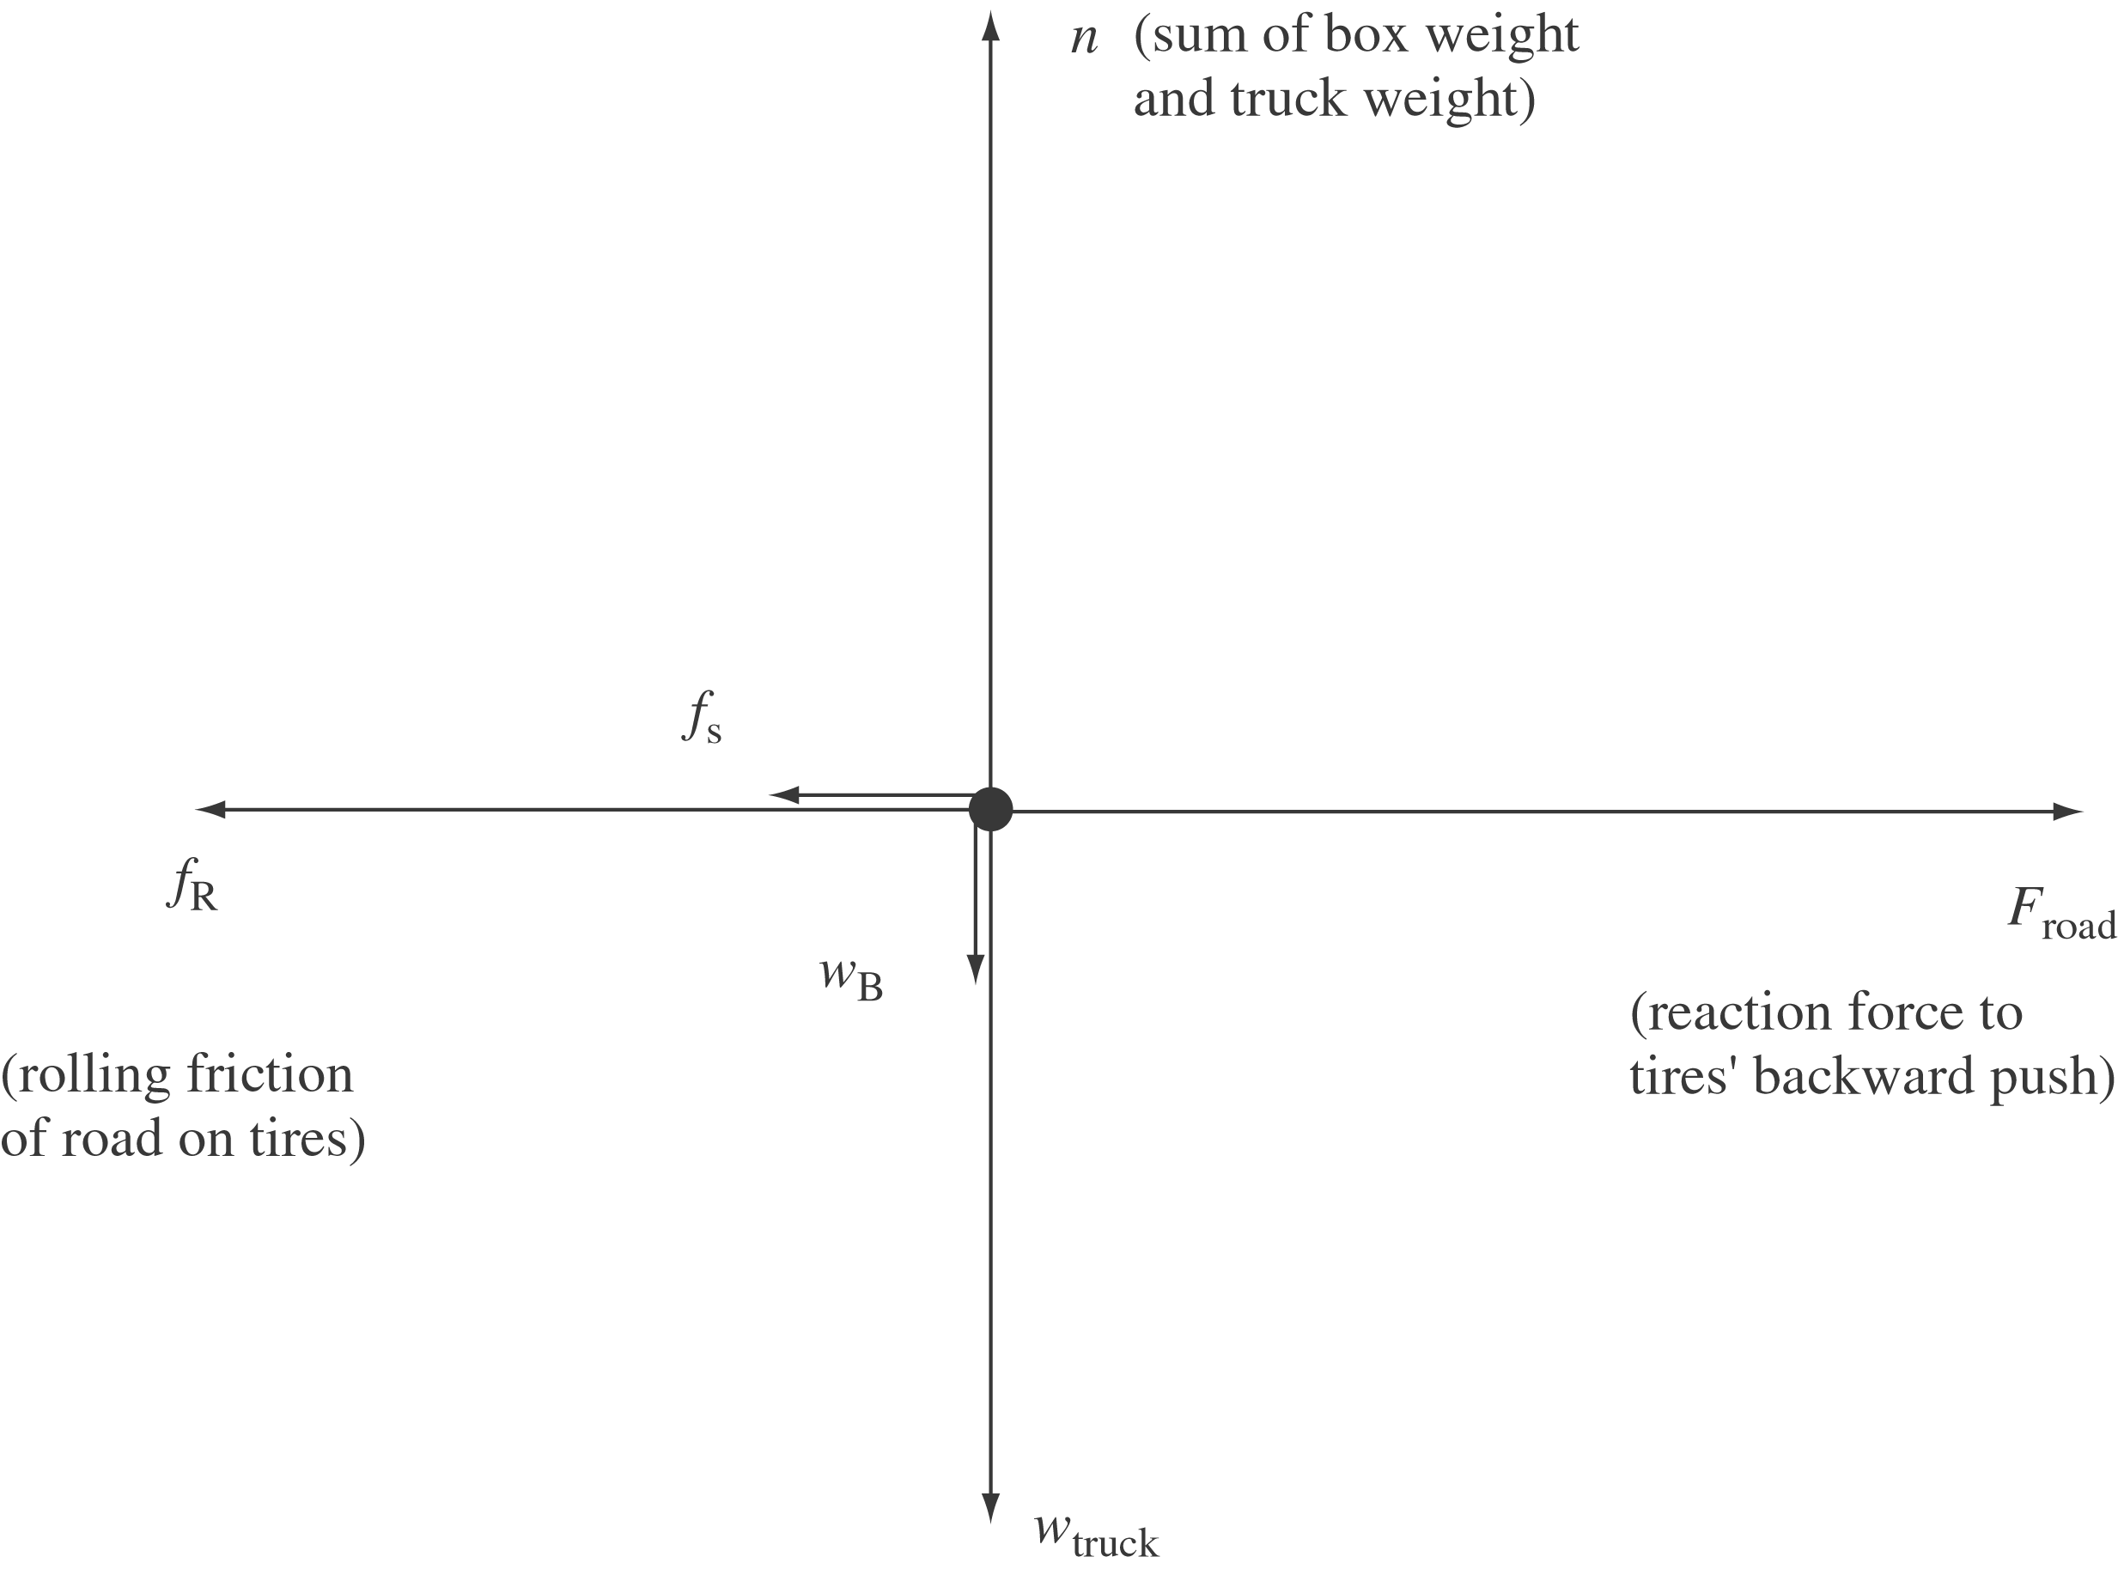
The box’s friction force on the truck bed and the truck bed’s friction force on the box form an action-reaction pair. There would also be some small air-resistance force action to the left, presumably negligible at this speed.

